**NAME OF STUDENT: ASHUTOSH ARDU**

**REGISTRATION NO OF STUDENT: 20BRS1262**

**SLOT: L19+L20**

**DATE: 4-3-2021**

**LAB EXPERIMENT 1**

**INTRODUCTION TO PROGRAMMING IN R**

**AIM:**

To perform basic operations in R and to work with Tables

**Question: DATA SET- POPULATION OF INDIA**

1. Consider the following dataset:

https://www.worldometers.info/world-population/india-population/

Population of India (2020 and historical)

| **Year** | **Population** | **Yearly % Change** | **Yearly Change** | **Migrants (net)** | **Median Age** | **Fertility Rate** | **Density (P/Km²)** | **Urban Pop %** | **Urban Population** | **Country's Share of World Pop** | **World Population** | **India Global Rank** |
| --- | --- | --- | --- | --- | --- | --- | --- | --- | --- | --- | --- | --- |
| 2020 | **1,380,004,385** | 0.99 % | 13,586,631 | -532,687 | 28.4 | 2.24 | 464 | 35.0 % | 483,098,640 | 17.70 % | 7,794,798,739 | 2 |
| 2019 | **1,366,417,754** | 1.02 % | 13,775,474 | -532,687 | 27.1 | 2.36 | 460 | 34.5 % | 471,828,295 | 17.71 % | 7,713,468,100 | 2 |
| 2018 | **1,352,642,280** | 1.04 % | 13,965,495 | -532,687 | 27.1 | 2.36 | 455 | 34.1 % | 460,779,764 | 17.73 % | 7,631,091,040 | 2 |
| 2017 | **1,338,676,785** | 1.07 % | 14,159,536 | -532,687 | 27.1 | 2.36 | 450 | 33.6 % | 449,963,381 | 17.74 % | 7,547,858,925 | 2 |
| 2016 | **1,324,517,249** | 1.10 % | 14,364,846 | -532,687 | 27.1 | 2.36 | 445 | 33.2 % | 439,391,699 | 17.75 % | 7,464,022,049 | 2 |
| 2015 | **1,310,152,403** | 1.20 % | 15,174,247 | -470,015 | 26.8 | 2.40 | 441 | 32.7 % | 429,069,459 | 17.75 % | 7,379,797,139 | 2 |
| 2010 | **1,234,281,170** | 1.47 % | 17,334,249 | -531,169 | 25.1 | 2.80 | 415 | 30.8 % | 380,744,554 | 17.74 % | 6,956,823,603 | 2 |
| 2005 | **1,147,609,927** | 1.67 % | 18,206,876 | -377,797 | 23.8 | 3.14 | 386 | 29.1 % | 334,479,406 | 17.54 % | 6,541,907,027 | 2 |
| 2000 | **1,056,575,549** | 1.85 % | 18,530,592 | -136,514 | 22.7 | 3.48 | 355 | 27.6 % | 291,350,282 | 17.20 % | 6,143,493,823 | 2 |
| 1995 | **963,922,588** | 1.99 % | 18,128,958 | -110,590 | 21.8 | 3.83 | 324 | 26.5 % | 255,558,824 | 16.78 % | 5,744,212,979 | 2 |
| 1990 | **873,277,798** | 2.17 % | 17,783,558 | 9,030 | 21.1 | 4.27 | 294 | 25.5 % | 222,296,728 | 16.39 % | 5,327,231,061 | 2 |
| 1985 | **784,360,008** | 2.33 % | 17,081,433 | 115,942 | 20.6 | 4.68 | 264 | 24.3 % | 190,321,782 | 16.10 % | 4,870,921,740 | 2 |
| 1980 | **698,952,844** | 2.32 % | 15,169,989 | 222,247 | 20.2 | 4.97 | 235 | 23.0 % | 160,941,941 | 15.68 % | 4,458,003,514 | 2 |
| 1975 | **623,102,897** | 2.33 % | 13,582,621 | 421,208 | 19.7 | 5.41 | 210 | 21.3 % | 132,533,810 | 15.27 % | 4,079,480,606 | 2 |
| 1970 | **555,189,792** | 2.15 % | 11,213,294 | -68,569 | 19.3 | 5.72 | 187 | 19.7 % | 109,388,950 | 15.00 % | 3,700,437,046 | 2 |
| 1965 | **499,123,324** | 2.07 % | 9,715,129 | -17,078 | 19.6 | 5.89 | 168 | 18.7 % | 93,493,844 | 14.95 % | 3,339,583,597 | 2 |
| 1960 | **450,547,679** | 1.91 % | 8,133,417 | -30,805 | 20.2 | 5.90 | 152 | 17.9 % | 80,565,723 | 14.85 % | 3,034,949,748 | 2 |
| 1955 | **409,880,595** | 1.72 % | 6,711,079 | -21,140 | 20.7 | 5.90 | 138 | 17.6 % | 71,958,495 | 14.78 % | 2,773,019,936 | 2 |

1. Create a data frame with the above data.

2. Find the summary of the whole data set. (Use appropriate syntax)

3. Find the mean, median for the population of India between 1955 and 2020 and justify your answer.

4. Find the variance, standard deviation of population of India and population of the world.

5. calculate the average density.

6. Any other notable analysis from the above dataset.

ANSWERS

1] Data frame:

Command:

a=read.csv("D:/VIT/First-Yr-Winter/Maths Practicals/Data/Lab1.csv")

a

Output:

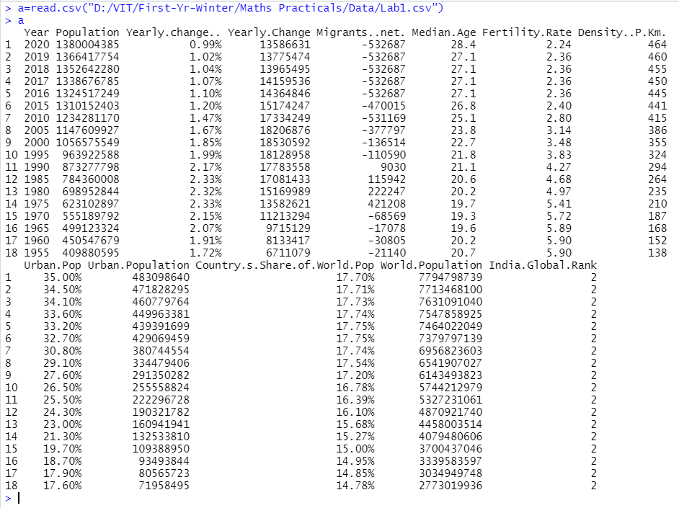

2]

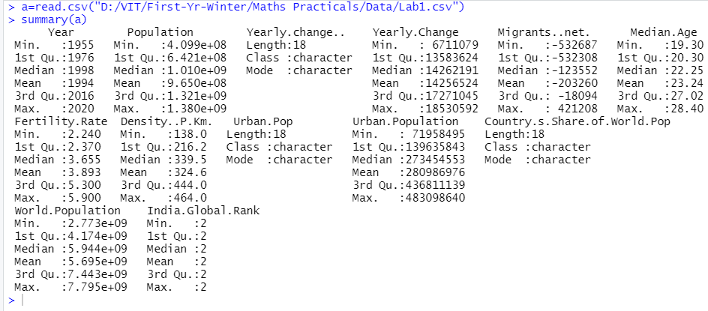

3]

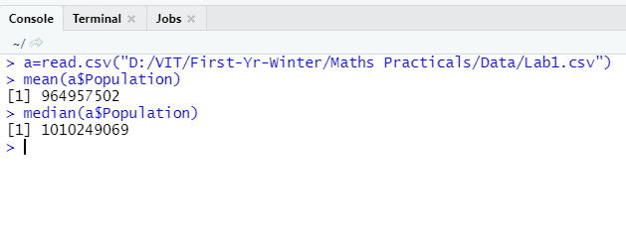

As we can see from the Data Frame shown before, from the year 1955 to 1995- which happens to be a 40 years gap-, India’s population plummeted from **409,880,595**  to a staggering **963,922,588** which is a **554,041,993** jump in population and has reached the margin of a billion and also crossed it in 1956. It continues to stay above it from then till the present year 2020 (which is a 25-year jump). In 2020, India has around 1.3 billion as its demographics. This sudden and continues rise in population causes the mean and median of India’s demographics to touch the 1billion.

4]

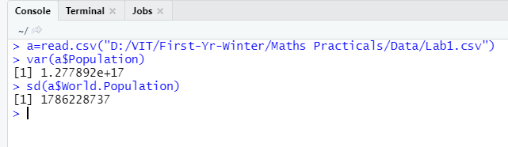

5]

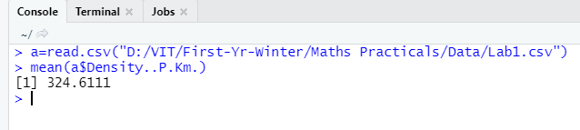

6]

The Overviews

In 1955, India was a country of **409,880,595** people who was just recovering from 200 years ( who happen to rule for about 200 years or more) of colonial rule and with the majority of the population facing poverty. Due to this poverty-ridden population, people started more as they felt insecure and also because at the times (around 1947) the country’s life expectancy was only about 27 years. From 1955 till 1975 country’s Fertility rate had plummeted up to 5.9 and stayed there till the fall of 1975 while the population (in 1960) was **450,547,679** with a total land area of **3,287,590** sq. km (becoming the 7th largest country and adds up to 2% to the world landmass but add up to 14.37% to world population), the country was innocent as to how this high Fertility rate could affect them, which later snowballed into a huge 1.3 billion (in demographics) in 2020(adding to about 17.7% to the world population while still being of the same size).

But with that being said India’s fertility rate has gone down ever since 1955 which was about 5.9 to around 4.9 in 1980 to 3.14 in 2005 and has come down even more to a value of 2.24 in 2020. And this has occurred as a result of India’s consistent development, its population got more educated and hence could easily support their families. Also, the rise in the country’s economy helped its health care services to rise as India went from 41 years of life expectancy in 1960 to an astonishing 70 years of life expectancy in 2018 and that’s just in 50 years from their republic freedom from the colonial rule and that to in a country where around 75% of the population is rural.

Due to this 75% being rural population and agriculture still being the backbone of the nation’s economy the countries must focus on developing or rather enhancing rural India rather than turning them into urban cities.